Article body: Top Local SEO Services help businesses appear on Google and Google Maps, making it easy for nearby customers to find them. These services improve website traffic, build trust through accurate listings and reviews, and attract high-intent local customers. By using expert strategies, businesses can grow steadily, stay ahead of competitors, and generate more leads and sales over time.
Meta description: Top Local SEO Services help your business appear on Google, attract local customers, boost leads, and grow steadily online.
Meta title: Top Local SEO Services Near Me to Boost Growth
Keyphrase: local SEO services

Top Local SEO Services Near Me to Boost Growth
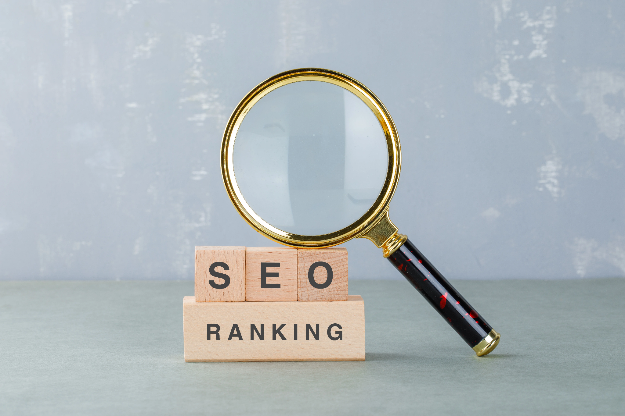
Top local SEO services help your business show up on Google when people near you search for products or services. This makes it easy for customers to find your business online. It brings more visitors to your website, helps you get new customers, and makes your business strong and trusted in your local area. They also improve your business reputation with good reviews and correct information. With local SEO, your business can grow steadily and stay ahead of nearby competitors.

Table of Contents
- What is Local SEO?
- Benefits of Professional Local SEO
- Key Elements of a Reliable Local SEO Service
- How Local SEO Helps Businesses Grow
- Local SEO vs Traditional SEO
- Choosing the Right SEO Partner
- Conclusion
- FAQs

What is Local SEO?
Local SEO Services help a business appear on Google when people search for shops or services near them. It shows the business on maps and local search results so customers can find it easily. Local SEO uses correct business details, good reviews, and a simple website. It helps attract people who are ready to visit the shop or contact the business.

Benefits of Professional Local SEO
Using Local SEO services helps any business get more customers. It shows the business higher on Google and on Google Maps, so people can find it easily. More people visit the website, trust the business because of good reviews, and remember the brand in the local area. Local SEO helps reach people who are already looking to buy or contact a service, so it works very well.

Key Elements of a Reliable Local SEO Service
A reliable local SEO service helps businesses appear higher in local search results and reach the right customers. It focuses on safe SEO methods, strong website performance, and local market understanding. These strategies help businesses grow steadily and avoid search engine penalties.
SEO Experts in Dubai: Professional SEO experts understand local search trends and competition. They create strategies that help businesses rank better in their target areas.
Technical SEO Company in Dubai: A technical SEO company improves website speed, structure, and mobile usability. This helps search engines and users navigate the website easily.
White Hat SEO Dubai: White hat SEO uses safe and ethical methods approved by search engines. It ensures long-term rankings and protects the website from penalties.
Keyword Research & Content Optimization: The right keywords and optimized content help businesses attract local customers. This makes the website more visible in local searches.
Local Citations & Listings: Accurate business details on online directories and maps improve trust and visibility. They help customers find the correct information easily.
Reporting & Performance Tracking: Clear reports show ranking progress, traffic growth, and results. This helps businesses understand how their local SEO is performing.

How Local SEO Helps Businesses Grow
Local SEO Services make it easy for people nearby to find your business online. They help attract more customers who are ready to buy or use your services. With the right strategies, businesses can grow steadily and stay ahead of local competitors.

SEO Consultant in Dubai
An SEO consultant makes a simple plan for your business to help more local customers find you easily. They check what your competitors are doing and find ways to make your business better. This helps more people visit your website or shop and become your customers.

Accurate Business Listings
Local SEO Services help put the correct business details online, which makes people trust your business. When your address and phone number are correct, customers can easily call or visit your shop.
It also helps new people find your business without any confusion. Good content on your website helps local people find your business when they are looking to buy something, bringing more visitors who are interested in your products or services.

Latest SEO Strategies
Using the latest SEO techniques ensures your business stays visible on search engines and adapts to updates over time. This helps your website keep attracting new customers and stay ahead of competitors.

SEO Consultation in Dubai
SEO consultation helps businesses see how they are doing, find ways to get better, and plan to grow in the future. It also shows what is working well and what needs to be fixed to get more customers.

Local SEO vs Traditional SEO Feature
Feature | Local SEO | Traditional SEO
Target Audience | People nearby | National or global audience
Search Focus | Location-based searches | Broad keywords
Google Maps | Very important | Less important
Conversion Rate | High | Moderate
Results Speed | Faster for local reach | Takes longer

Choosing the Right SEO Partner
- Selecting the right SEO partner is critical for success.
- Look for transparency, ethical methods, experience, and a clear strategy.
- A good SEO partner helps your business grow little by little in a safe way.
- They show you real results and make a plan just for your business, not using quick tricks.
- Local SEO experts know other businesses in your area and use smart ways to bring more visitors and customers to you.

Conclusion
Local SEO helps your business grow in your area. It makes your business easier to find, builds trust, and brings customers who are looking for nearby services. With the help of experts and safe methods, Local SEO Services give long-term results. Using professional SEO services helps your business show up on Google, get more customers, and grow little by little over time. Start using local SEO today to reach more customers in your area. Contact a professional SEO service and give your business the boost it needs.

FAQs
Q1: What are local SEO services?
Local SEO services help your business show up on Google and maps when people nearby are looking for your products or services.
Q2: How long does local SEO take to show results?
Local SEO usually starts showing results in 3 to 6 months. It depends on how many other businesses are competing and how good your website is.
Q3: Is local SEO useful for small businesses?
Yes, it is highly effective for small businesses because it targets customers who are ready to take action locally.
Q4: Are local SEO strategies different from regular SEO?
Yes, local SEO emphasizes geographic targeting, business listings, reviews, and local content.
Q5: Can local SEO increase leads and sales?
Yes, by reaching high-intent users, local SEO helps generate quality leads and improve conversions.

